1.13.3-ALG matchResume() Algorithm
Purpose:
This algorithm evaluates whether a student's resume meets a set of required job skills. It retrieves the specified resume, compares the skills listed in the resume against the required skills, calculates the number of matches, and returns a result indicating whether the resume satisfies all required criteria.
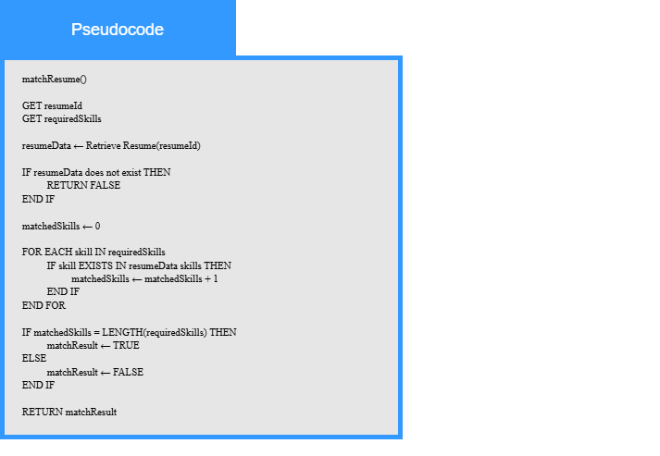
Local Data:
resumeData : Resume
requiredSkills : List of Skills
matchedSkills : Number
matchResult : Boolean

